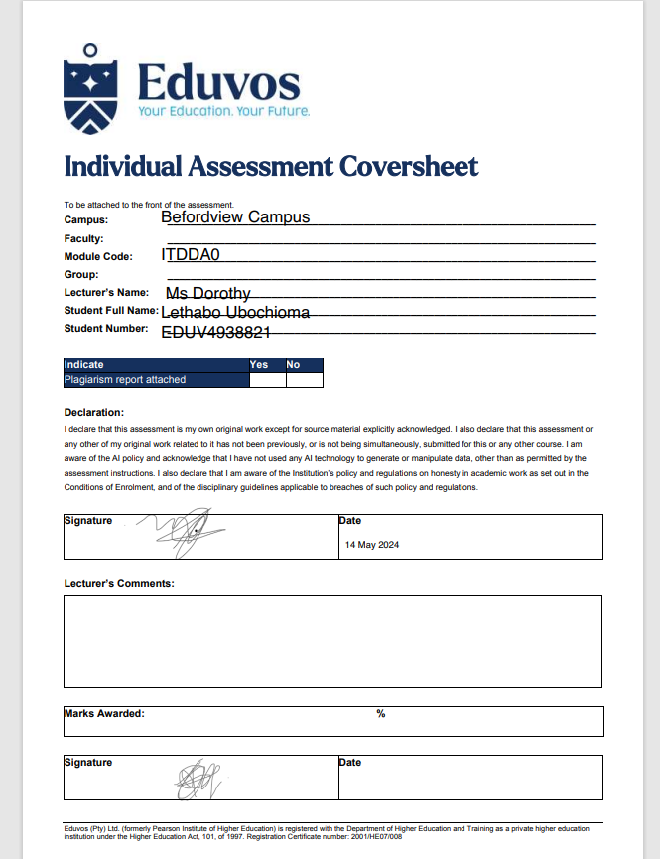

INDEX

PROJECT SPECIFICATION :
- INTITAL ER DIAGRAM , PAGE 3
- NORMALISATION , PAGE 4 – 7
- MAPPING OF THE TABLE , PAGE 8
- DOCUMENTATION , PAGE 9 – 10

PROJECT 3 : A South African Booking Agency .
SECTION A :
QUESTION 1 :
INITIAL ER DIAGRAM
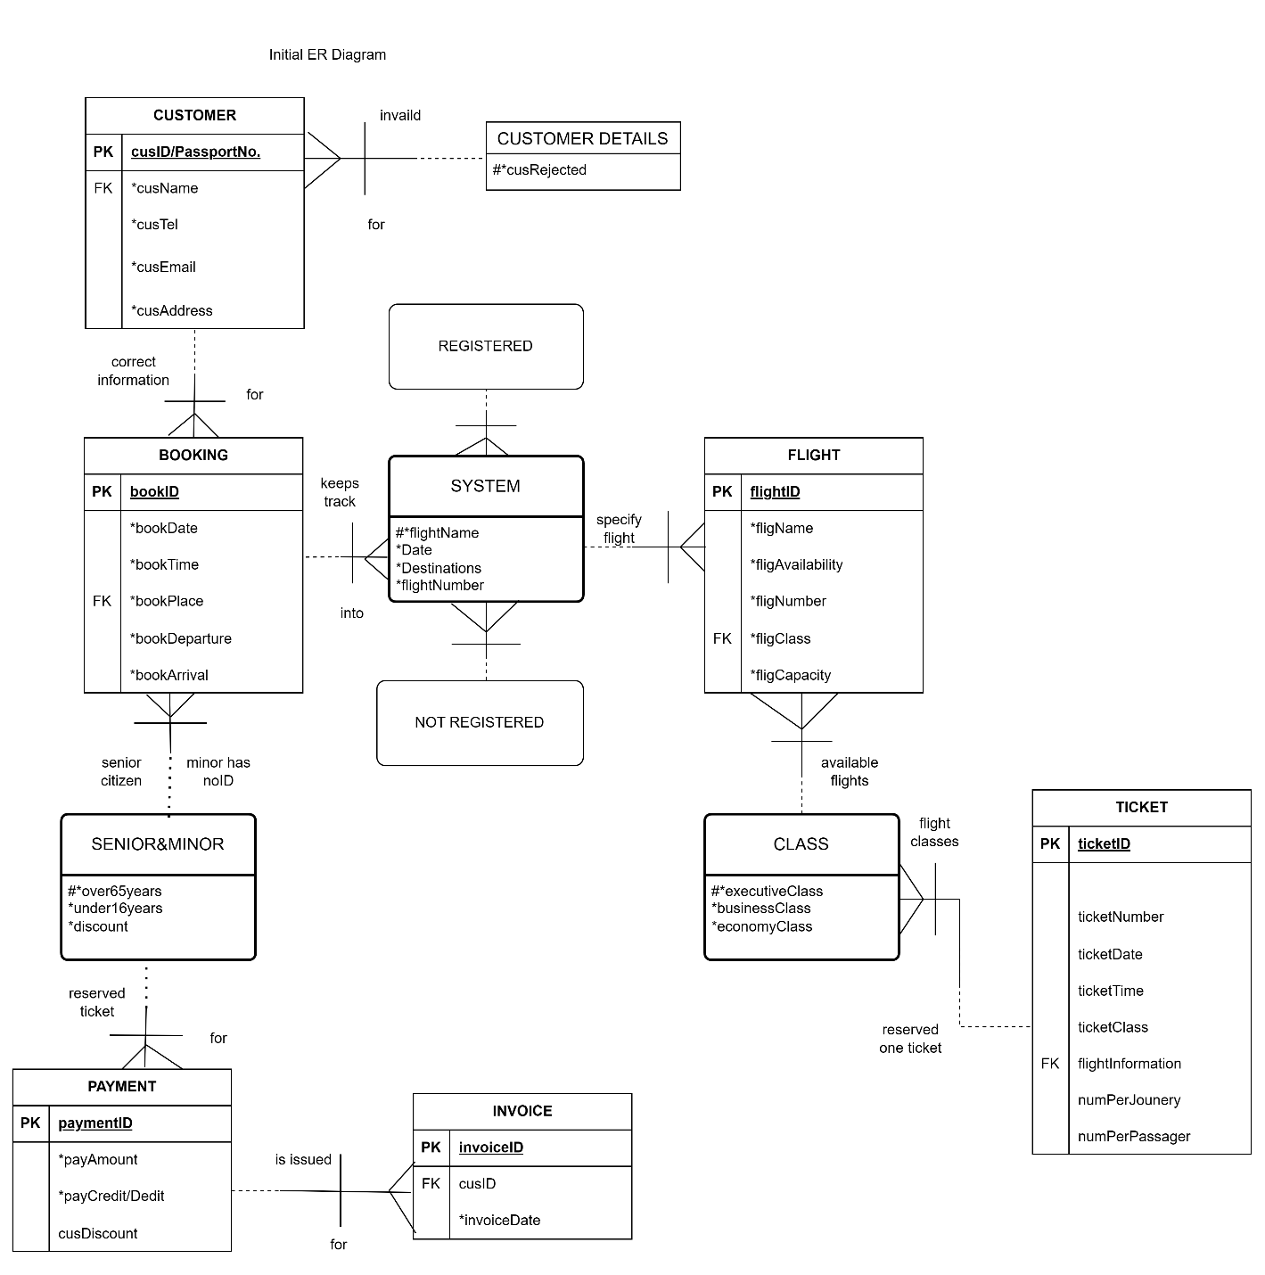

NORMALISATION
ZERO NORMAL FORM ( 0ZNF)

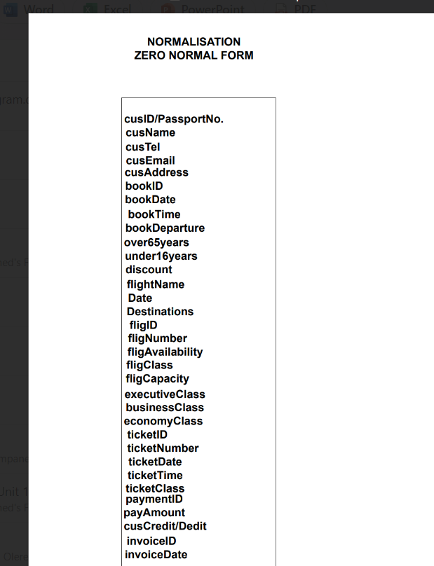

FIRST NORMAL FORM

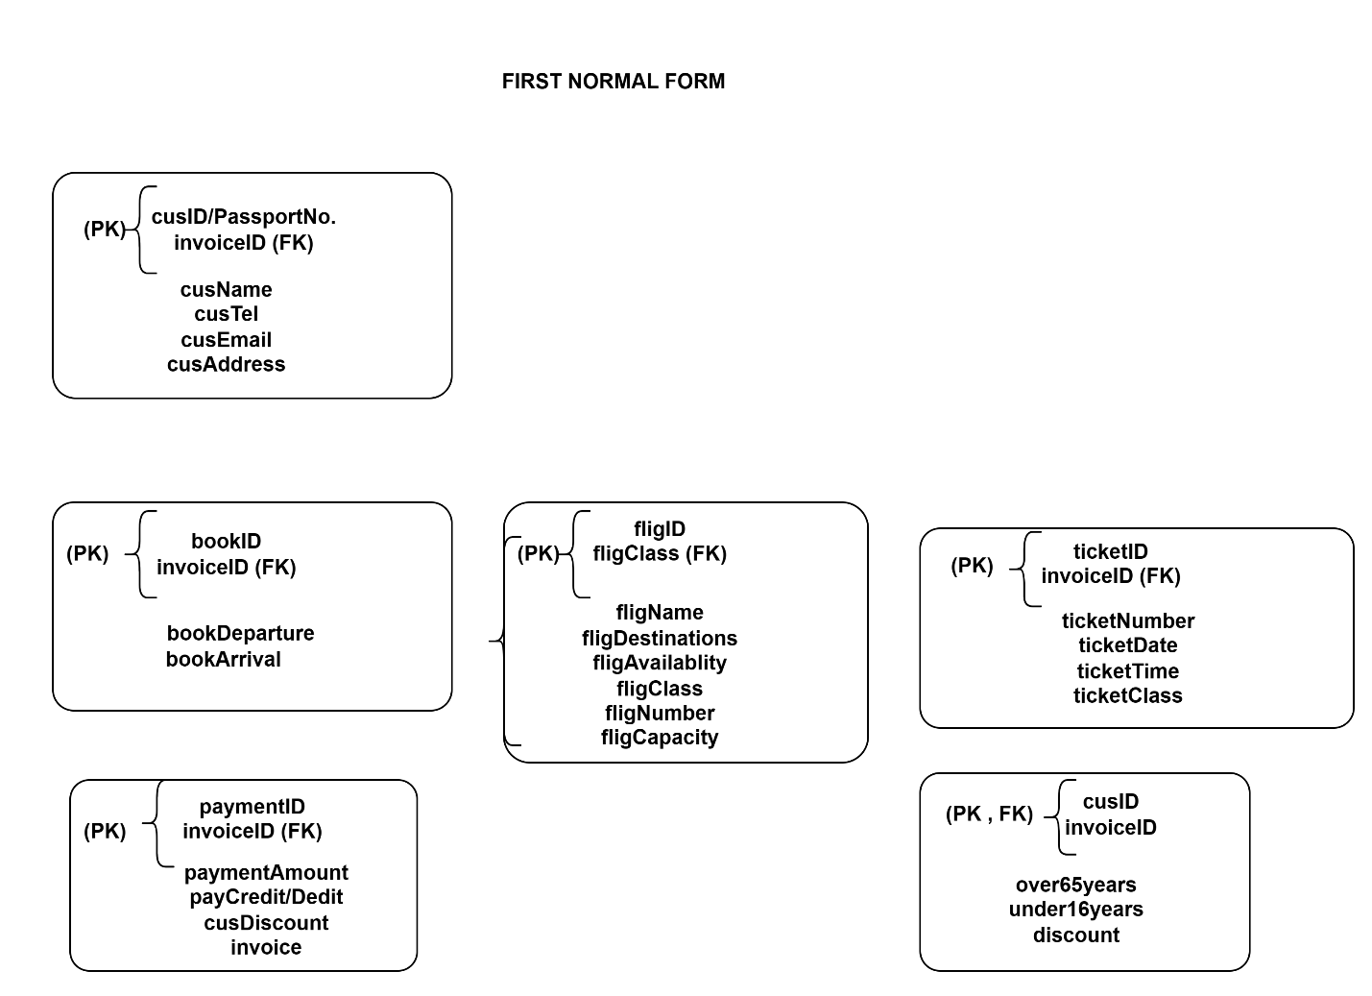

SECOND NORMAL FORM

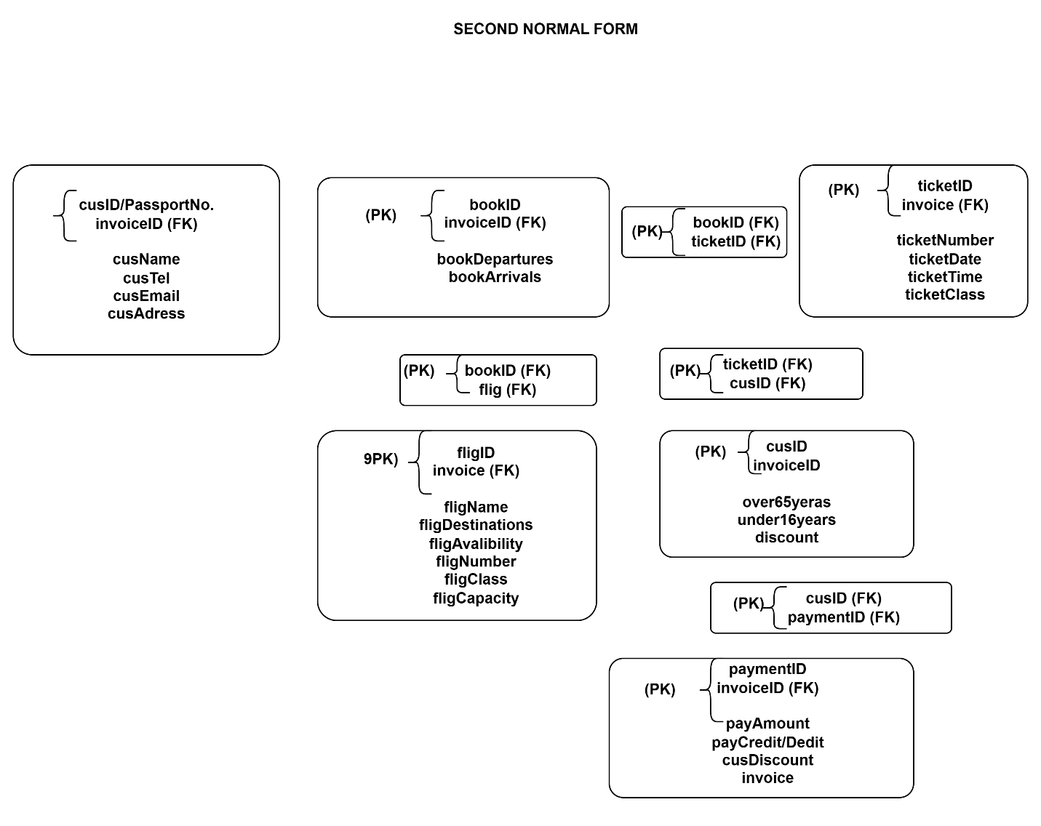

THIRD NORMAL FORM

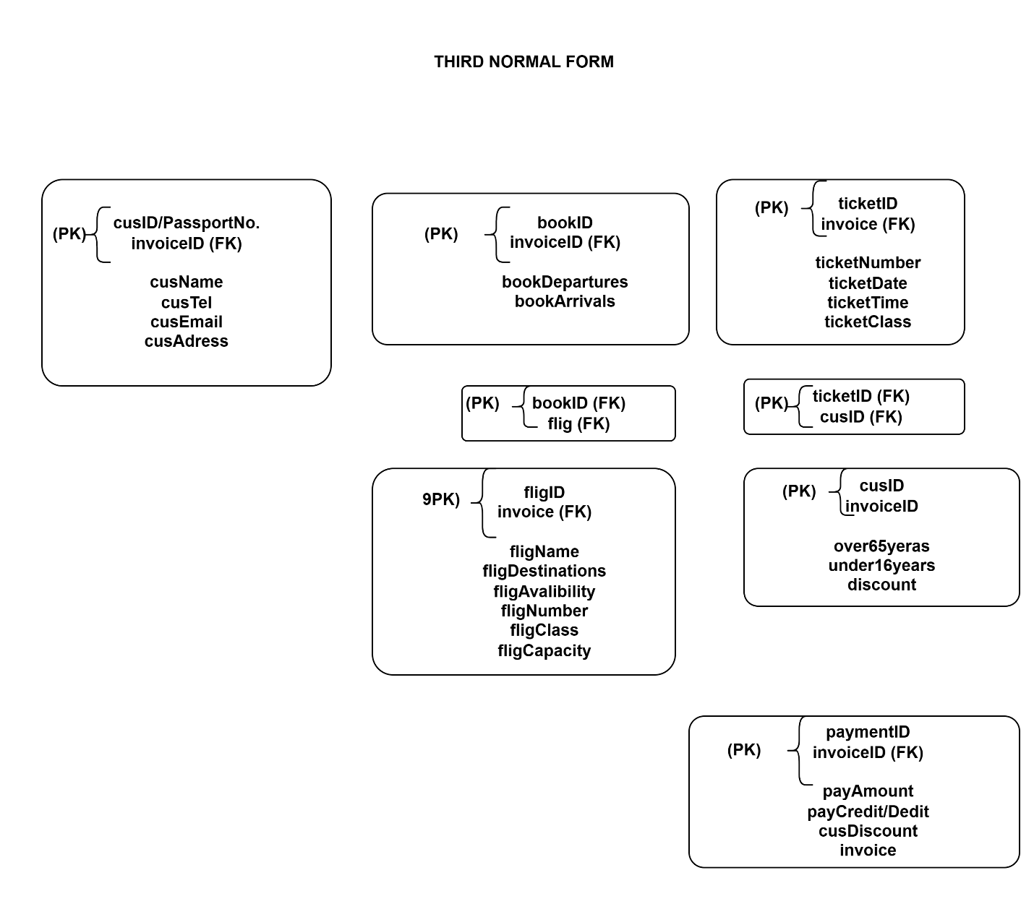

3NF ER DIAGRAM (Another diagram from third normal form ) :

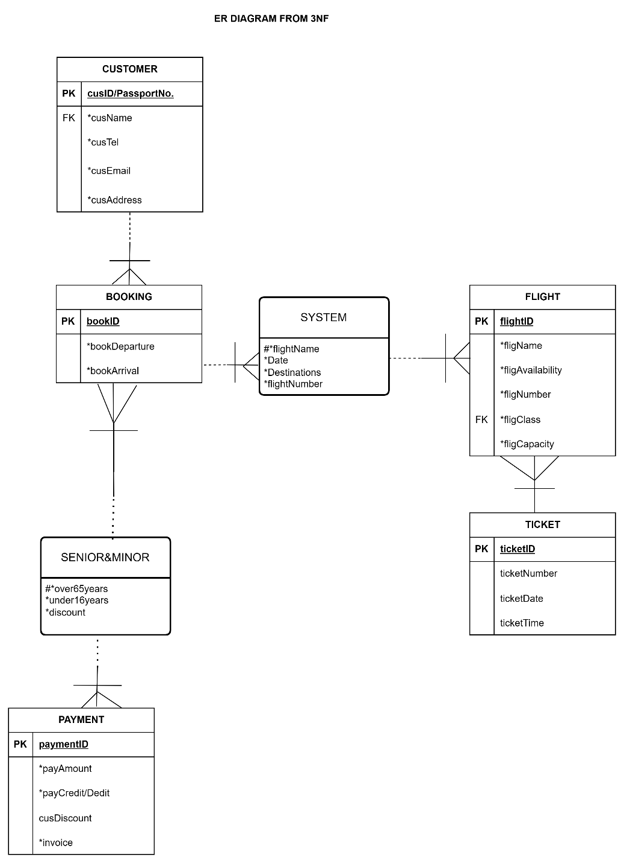

MAPPINF OF THE TABLE ;

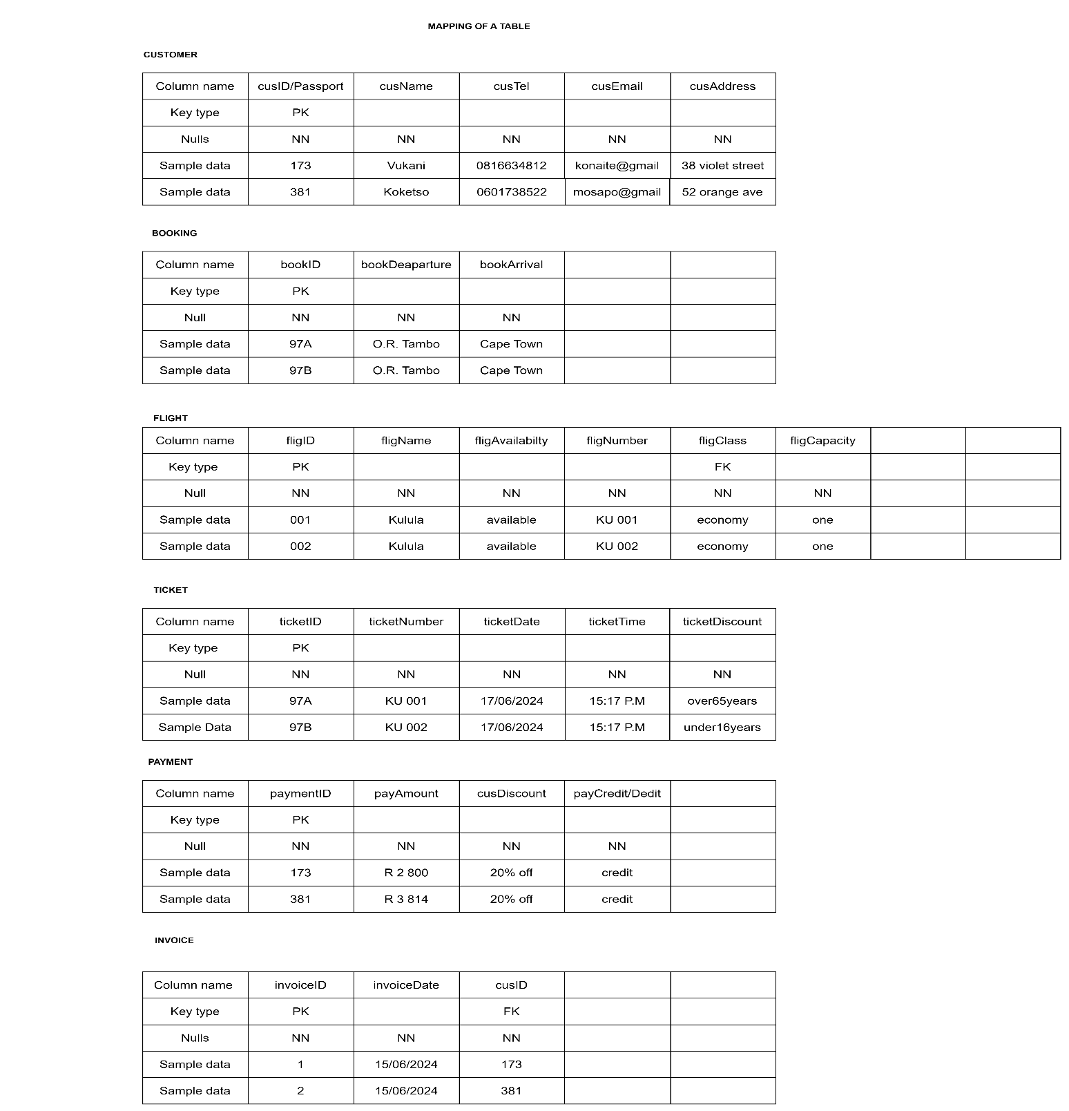

DOCUMENTATION
Author : Lethabo Ubochioma
Date : 14th May 2024
Lecturer : Ms Dorothy
Campus : Bedfordview

THE PURPOSE OF THE PROJECT IS TO DESIGN AN ONLINE BOOKING AGENCY SYSTEM .

- Customers/ Clients that are registered in the system are safe for booking but, this time the system is going keep track of online bookings that have been made by customers that usually booking with this agency . Accommodate both registered and unregistered customers .

- For registration , customers/ clients have to enter their information such as “personal details” . if a customer enters an invalid information , the system will reject the customer .

- When a customer is registered , the system captures that and they can book . Booking also requires details from the customer about , where they want travel and if they can afford booking it online . The online gives plenty of options and choices for our customers , once a customer makes a choice , the system keeps track of the booking that is reserved . When booking , the system will check if ther are an available flights and when available , the availability of class will be shown for customer to choose .

- A ticket has a discount purchase for seniors who are over 65 years old and for minors who are under 16 years old . When a customer chooses to book online then a payment is made and an immedate invoice is sent to the customer/client .
In conclusion , the ER diagram changed from its initial to third normal form diagram . The mapping of the table gives clear and accurate information on who the customer and how the system keeps the information of the booking process . It shows a better understanding and proper order . Redundancy and duplication and traps must be removed during the normalisation stage , this stages ensures everything goes well .

